 | Autumn 1 –  All about me! | Autumn 2 –  The Night Sky  (Space and Celebrations) | Spring 1 –  Houses, Homes and Habitats | Spring 2 -  Superheroes | Summer 1  Growth and Our World | Summer 2 –  Fun at the Seaside!
Focus Topics | -Starting School  -My new class  -Routines and rules  -Ourselves – what am I good at?  -My Body – keeping ourselves healthy  -My Family  -Being Kind  -Autumn/ Harvest  -The Colour Monster | -Celebrations and festivals (Remembrance Day Halloween, Diwali, World Space Week, Guy Fawkes/ Bonfire Night, Christmas)  -Space  -Light and Dark  -Autumn into Winter | -Where do I live?  -Local area  -Contrasting environments and habitats  -Different cultures  -Climates  -Polar regions  -Winter  -Hibernation  -Chinese New Year  -Pancake Day | -People who help us  -Signs of Spring  -Easter  -Recycling  -Looking after our world  -Superheroes  -World Book Day | -Farms  -New life (plants and animals)  -Life cycles  -Growing  -Minibeasts  -Healthy eating  -Food from around the world | -Underwater worlds  -Seaside  -Seaside past and present  -Holidays and travel  -Travel transport  -Transition into Year 1
Key Events/Wow Moments | -Making bread for the Little Red Hen  -Make pumpkin soup/cake  -Farmer visit to school  -Signs of Autumn  -Harvest  -Library visit  -Forest School Friday | -Supermarket trip to buy gingerbread ingredients  -Bake gingerbread  -Nativity play  -Christingle service at church  -Celebrations:  Remembrance, Halloween, Diwali, World Space Week, Guy Fawkes/ Bonfire Night  -Forest School Friday | -Bear hunt around school grounds  -Food tasting from around the world  -Chinese New Year – food tasting, dancing, role play  -Making, decorating, and eating pancakes  -Walk around the local area – park  -Beacon Fell  -Forest School –habitats focus  -Library visit  -Forest Friday | -Visits from police, paramedics, vets, dentists etc.  -Fire station visit  -Superhero Day at school  -Easter egg hunt  -Library visit  -World Book Day  -Forest Friday | -Windmill Farm visit  -Garden Centre visit  -Making fruit smoothies  -Caterpillars and chicks in school  -Pizza express visit – making pizzas  -Lancaster Butterfly House  -Forest Friday | -Aquarium visit to Blackpool Sea life Centre  -Lytham St Annes seaside visit  -Pirate Fun Day at school  -Teddy Bears Picnic in school  -Making porridge – Goldilocks and the Three Bears  -Forest Friday
Reading in EYFS

Traditional Tales/ T4W texts | 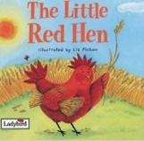  The Little Red Hen | The Gingerbread Man  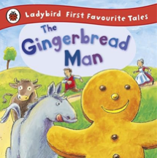 | 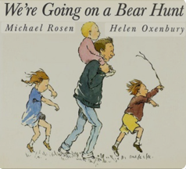  We’re Going on a Bear Hunt | The Three Little Pigs  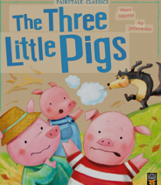 | 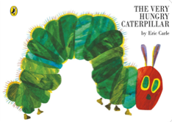  The Very Hungry Catterpillar | Goldilocks and the Three Bears  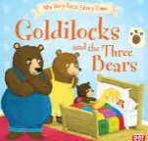
Wellbeing | 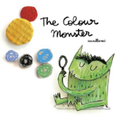  The Colour Monster – Anna Llenas | Ruby’s Worry – Tom Percival  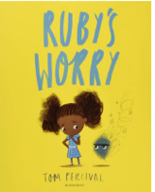 | Perfectly Norman – Tom Percival  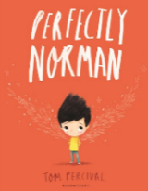 | Tough Guys have Feelings Too – Keith Negley   | 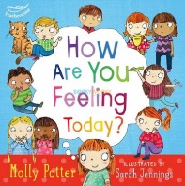  How are you Feeling Today? -Molly Potter | 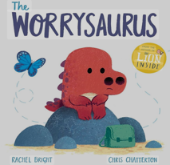  The Worrysaurus – Rachel Bright
Diversity | 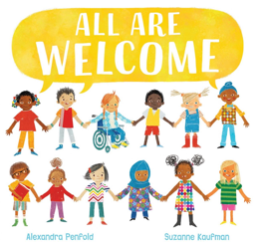  All are welcome – Alexandra Penfold | Let’s Celebrate – K.DePalma  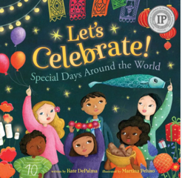 | In Every House, on Every Street – Jess Hitchman  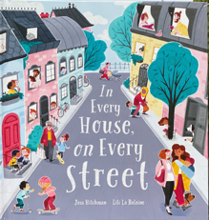 | 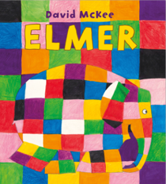  Elmer – David McKee | Hair Love – Matthew A. Cherry  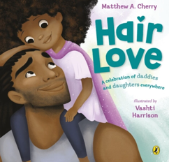 | 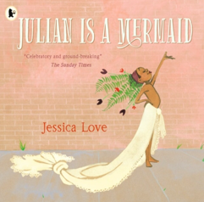  Julian is a Mermaid – Jessica Love
Repetitive refrain/Rhyming | Oi Frog – Kes Gray and Jim Field  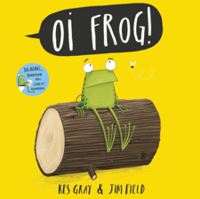 | Where the Poppies Now Grow – Hilary Robinson  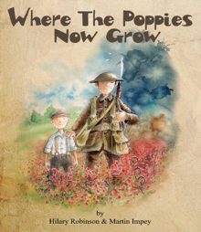 | 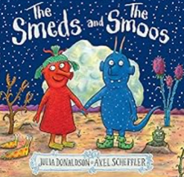  The Smeds and the Smoos – Julia Donaldson | 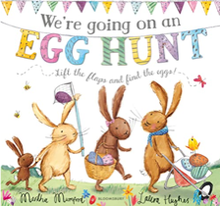  We’re Going on an Egg Hunt – Laura Hughes and Martha Mumford | 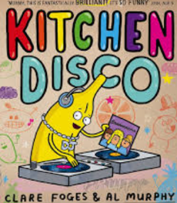  Kitchen Disco – Clare Foges | 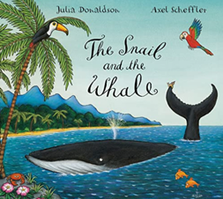  The Snail and the Whale – Julia Donaldson
Modern texts  (written in the last 3 years) | What the Worm Saw – Emil Fortune  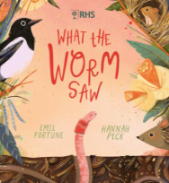  This is me! – George Webster  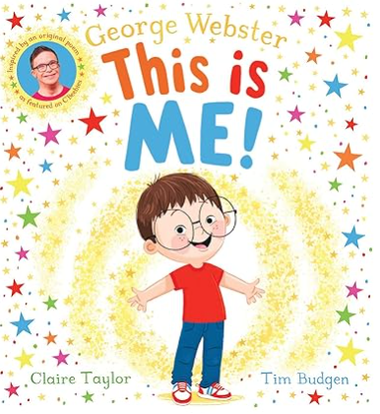 | Snail in Space – Rachel Bright  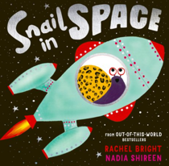  Percy the Post Penguin – Genevieve Aspinall  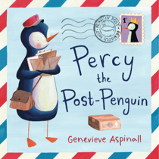 | Confetti – A colourful celebration of love and life – Dean Atta  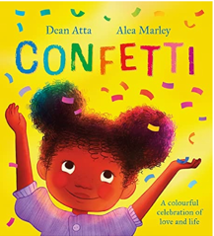 | All Through the Night: The People Who Work While We Sleep – Polly Faber  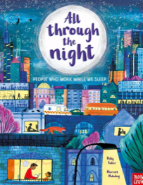 | 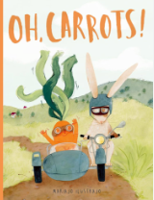  Oh, Carrots! – Mariajo Ilustrajo | 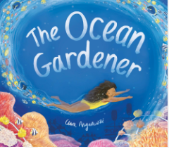  The Ocean Gardener – Clara Anganuzzi
Rhyme, Poems & Songs | Old MacDonald had a farm…  Chick, Chick, Chicken  Mary had a little lamb  Farmers in the den  Little Boy Blue | I am the Baker Man  Pat a cake, Pat a cake  Twinkle Twinkle little star  I’m a little teapot  5 little speckled frogs | The Bear went over the mountain  We’re marching in our wellingtons  Five little bears jumping on the bed  Incy wincy spider | This little piggy went to market  Horsie, horsie don’t you stop  I can sing a rainbow  1,2,3,4,5, once I caught a fish alive… | There’s a tiny caterpillar on a leaf  Wiggly woo  Down in the jungle  Humpty Dumpty  Ten green bottles | When Goldilocks went to the house of bears…  Little Miss Muffet  Little Bo Peep  The Magic Porridge Pot  The sun has got its hat on
Other texts | Starting School – Janet and Alan Ahlberg  Topsy and Tim Start School – Jean Adamson  The Colour Monster goes to School – Anna Llenas  When a Dragon Goes to School – Caryl Hart  Kippers First Day  The Leaf Thief – Alice Hemming  Pumpkin Soup – Helen Cooper  Scarecrows Wedding – Julia Donaldson | The Gruffalo and The Gruffalo’s Child – Julia Donaldson  Stick Man – Julia Donaldson  Owl Babies – Martin Waddell  How to Catch a Star – Oliver Jeffers  Whatever Next! – Jill Murphy  The Best Diwali Ever – S.Shah  We’re going on an Elf Chase – Martha Mumford  Little Glow – Katie Sahota | Poles Apart! - Jeanne Willis  That’s not my Polar Bear! – Fiona Watt  On the Way Home – Jill Murphy  Look Up! – Nathan Bryon  Over and Under the Snow – Kate Messner  A Place Called Home – Kate Baker  Building a Home – Polly Faber | Supertato – Sue Hendra  Somebody Swallowed Stanley – Sarah Roberts  Mog and the VET – J.Kerr  Stella and the Seagull – Georgina Stevens  Michael Recycle – Ellie Bethel  Tidy – Emily Gravett  Busy People books – Lucy M.George | Where Does My Food Come From? – Annabel Karmel  Farm Hullabaloo – Giles Andreae  Farmer Duck – Martin Waddell  Pip and Egg – Alex Latimer  A Squash and a Squeeze – Julia Donaldson  What the Ladybird Heard – Julia Donaldson  Argh Spider! – Lydia Monks | The Sea Below My Toes – Charlotte Guillain  The Whale Who Wanted More – Rachel Bright  Tiddler – Julia Donaldson  Billy’s Bucket – Kes Gray  The Giant Jam Sandwich – Janet Burroway  National Trust: Big Outdoors for Little Explorers: Seaside – Anne-Kathrin Behl

Autumn 1 – All about me!
Prime Areas

PSED |  |  | Physical Development |  | Communication and Language
Self-regulation | Managing Self | Building Relationships | Gross Motor Skills | Fine Motor skills | Listening, Attention and Understanding | Speaking
Learning how to recognise their emotions and how to manage them.  To listen to others and track the speaker. | New beginnings.  Seeing themselves as a valuable individual.  Learning to wait  Following simple instructions.  Being able to wash and dry their hands.  Being able to follow class routines and rules. | Making new friends  Building new relationships with staff and pupils.  Learning to share with others. | Squiggle while you Wiggle  Tummy Time  Cooperation games (parachute games)  Dance (exploring different ways of moving).  Developing good personal hygiene (being able to wash their hands properly, brush their teeth, get dressed and undressed etc.)  Climbing on outdoor equipment.  Demonstrating fundamental movement skills. | Dough Disco  Daily name writing activities (in sand, slime, foam, chalk, paint, pencils using loose parts etc.)  Funky finger activities (threading, cutting, weaving, playdough, tweezers etc.)  Show preference for dominant hand.  Pencil grip (tripod grip to be encouraged).  Building models  Using cutlery and feeding themselves independently. | To listen to others and track the speaker.  Meeting new friends.  Carpet time – focusing on sitting in their carpet space and listening to the teacher.  Listening to their name in the register.  Taking part in guided reading sessions. | Meeting new friends  Circle time – sharing experiences with others.  Taking part in group discussions.  Taking part in discussions with their peers and adults during provision activities and golden story time.  Responding to their name in the register and ordering their lunch option.  Express verbally their needs/ wants to an adult.  Taking part in story time, singing, rhymes, poetry and phonics lessons.  Talking to the class bear ‘Barnaby’.

My Happy Minds (PSHE)
Module 1 – Meet your brain
Lesson 1 – What does our brain look like and what does it help us with?
Lesson 2 – How do we look after our brain?
Lesson 3 – How can we grow our brains?

Specific Areas
Literacy |  |  | Mathematics | Understanding the World |  |  | Expressive Arts and Design
Comprehension | Word Reading | Writing |  | Past and Present | People, Communities and Culture | Natural World | Creating Materials | Being Imaginative and Expressive.
Listen to stories and be able to demonstrate an understanding by answering questions.  Joining in with rhymes and showing an interest in stories with repeated refrains.  Sequencing familiar stories through the use of pictures.  Learning new vocabulary. | Recognise their name written down.  Identify initial letters for objects.  Verbally blend CVC words. | Use a dominant hand to mark make and form letters.  Pencil grip (tripod grip encouraged)  Have a go at writing their name independently.  Story scribbling.  Mark making in provision areas. | Maths – No Problem!  Number and pattern – Matching  Compare quantities up to 10 in different contexts.  Number and pattern – Sorting  Compare quantities up to 10 in different contexts.  Shape, space and measure – Comparing and ordering  Compare quantities up to 10 in different contexts.  Explore and represent patterns within numbers up to 10.  Number and pattern – AB patterns  Explore and represent patterns within numbers up to 10. | Talk about their families and pets  Discuss their house and where they live.  Discuss where they have been on holiday/ day trips.  Compare school to nursery.  Talk about harvest and autumn and comment on the seasonal changes.  Talk about themselves and the parts of their body.  Discuss their life and their past as a baby and toddler.  Role play – home setting.  Exploring what makes a family.  Developing an understanding of the role of a farm during harvest.  Explain what animals would be found on a farm.  Encourage interactions with the outdoors to foster curiosity. |  |  | Art  Self Portraits  Exploring paint and mark making using a range of different media.  Colouring mixing using the primary colour paints  Creating faces – using playdough, loose parts etc.  Junk modelling – making monsters  Creating clay hedgehogs  Making pumpkin soup  Baking bread  Music  Morning class songs  Nursery rhymes and poems  Charanga ‘Me!’ unit  Making music using the instruments during provision  Creating their own music instruments in the junk modelling area and during outdoor learning  Squiggle While You Wiggle  Small World play  Home corner  Role play areas  ‘The Studio’ art room

Outdoor Learning (Forest Fridays)
-The Little Red Hen
-Make flatbread on the fire
-Signs of Autumn walk
-Dig the mud pit area
-Intro the fire rules
-Intro the forest school rules
-Make soup potions
-Make a scarecrow

Autumn 2 – The Night Sky (Space and Celebrations)
Prime Areas

PSED |  |  | Physical Development |  | Communication and Language
Self-regulation | Managing Self | Building Relationships | Gross Motor Skills | Fine Motor skills | Listening, Attention and Understanding | Speaking
Show an understanding of their own feelings.  Being able to wait for what they want.  Giving focused attention of what the teacher says.  To listen to others and track the speaker. | Try new activities  Know right from wrong  Managing basic needs (toilet, washing hands, choosing healthy food options, getting dressed and undressed).  Show independence during certain activities. | Making new friends  Building relationships with staff and pupils  Turn taking  Sharing | Squiggle while you Wiggle  Ball skills – throwing and catching  Climbing on outdoor equipment.  Skipping ropes in outside area  Dance related activities  Provide a range of wheeled resources for children to balance, sit or ride on, or pull and push.  Two-wheeled balance bikes and pedal bikes. | Dough Disco  Daily name/ CVC writing activities  Funky fingers area – threading, cutting, weaving, playdough.  Develop muscles to put pencil pressure on paper.  To use different tools and media when create art and mark making.  Show preference for dominant hand.  Teach and model correct letter formation. | To listen to others and track the speaker.  Carpet time – focusing on sitting in their carpet space and listening to the teacher.  Listening to their name in the register.  Taking part in guided reading sessions.  Listening to stories being told.  Start to hold conversations when engaged in back-and-forth exchanges with their teacher and peers. | Circle time – sharing experiences with others.  Taking part in group discussions.  Taking part in discussions with their peers and adults during provision activities and golden story time.  Responding to their name in the register and ordering their lunch option.  Express verbally their needs/ wants to an adult.  Taking part in story time, singing, rhymes, poetry and phonics lessons.  Talking to the class bear ‘Barnaby’.  Nativity Play  Phonics sessions and guided reading

My Happy Minds (PSHE)
Module 2 – Celebrate
Lesson 1 –What are the superpowers (character strengths)? What is love and kindness?
Lesson 2 – What is bravery and honesty and teamwork and friendship?
Lesson 3 – What is exploring and learning and love of life and our world?

Specific Areas
Literacy |  |  | Mathematics | Understanding the World |  |  | Expressive Arts and Design
Comprehension | Word Reading | Writing |  | Past and Present | People, Communities and Culture | Natural World | Creating Materials | Being Imaginative and Expressive.
Retell stories related to events through acting/ role play and during ‘golden story’ time.  Retelling stories using images.  Editing of story/text maps and orally retelling new stories.  Sequence a story using the vocabulary ‘beginning, middle and end’.  Enjoys an increasing range of books.  Can choose books that they know will interest them. | Confidently blend and segment CVC words.  Recognise the letters in the alphabet.  Say a sound for each letter of the alphabet.  Read tricky words ‘to, into’. | Practise writing their name.  Use a dominant hand to mark make and form letters.  Pencil grip (tripod grip encouraged).  Begin to write CVC words with identifiable letters.  Label images.  Story scribbling.  Mark making in provision areas. | Maths - No Problem!  Number and pattern – Counting  Have a deep understanding of numbers up to 10.  Number and pattern –  Counting  Compare quantities up to 10 in different contexts.  Shape, space and measure-  Time  Explore and represent patterns within numbers up to 10.  Number and pattern – Composition of numbers up to five  Have a deep understanding of numbers up to 10. Subitise.  Number and pattern - Composition of numbers up to five  Automatically recall (without reference to rhymes, counting or other aids) number bonds up to 5.  Shape, space and measure – 2D shapes  Provide rich opportunities for children to develop their spatial reasoning skills across all areas of mathematics including shape, space and measures.  Shape, space and measure – Positional Language  Provide rich opportunities for children to develop their spatial reasoning skills across all areas of mathematics including shape, space and measures. | Explore the similarities and differences in festivals and recognise that people celebrate in different ways.  Recall special experiences and events.  To experience different special events and festivals through the use of role play.  Remembrance Day – discussing the past and the significance of this day.  Discuss the links between. Christmas, the Nativity Story and the school’s Nativity play.  Role play – Christmas home scene  Exploring light and dark – how can we see in the dark?  Exploring Space – how can we get to space? What is NASA? What is the role of an astronaut?  Explore nocturnal animals – which animals are nocturnal?  Encourage interactions with the outdoors to foster curiosity. |  |  | Art  Colouring mixing  Poppy paintings  Space paintings  Diva lamps  Christmas keepsakes and decorations (cards, stained glass ornaments, baubles, baking gingerbread etc).  Firework paintings  Rocket models  Music  Morning class songs  Nursery rhymes and poems  Charanga ‘My Stories’ unit  Making music using the instruments during provision  Creating their own music instruments in the junk modelling area and during outdoor learning  Squiggle While You Wiggle  Nativity Performance  Christmas Carols  Performing stories (T4W)  Small World play  Home corner  Role play areas  ‘The Studio’ art room

Outdoor Learning (Forest Fridays)
-The Gingerbread Man
-Mud gingerbread men
- Mud painting
- Clay Diwali lights
- Room on a broom trail
-Gruffalo trail Gruffalo art
-Rudolph art?
-Make potions in cauldrons
-Stickman

Spring 1– Houses, Homes and Habitats
Prime Areas

PSED |  |  | Physical Development |  | Communication and Language
Self-regulation | Managing Self | Building Relationships | Gross Motor Skills | Fine Motor skills | Listening, Attention and Understanding | Speaking
Control their own feelings and behaviours.  Behave in ways in which are socially acceptable.  Apply personalised strategies to return to a state of calm (self-regulate).  Able to concentrate on a task. | Show an understanding of their own and others’ feelings.  Learning about what qualities they have.  To be confident to participate in new activities.  Understanding the reasons for rules.  Can follow classroom routines and rules confidently.  Behave appropriately towards different people. | Maintaining friendships.  Turn taking.  Sharing.  Playing with each other.  Trusting others. | Ball skills – aiming, dribbling, pushing, throwing and catching, patting or kicking.  Provide a wide range of activities to support a broad range of abilities.  Dance/ moving to music.  Gymnastics/ balance. | Daily name/ CVC writing activities.  Funky fingers area – threading, cutting, weaving, playdough etc.  Begin to form letters correctly.  Handle tools, objects, construction and malleable materials with increasing control.  Encourage children to draw freely.  Encourage children to hold small items, button and zip up clothing, cut with scissors. | To listen to others and track the speaker.  Carpet time – focusing on sitting in their carpet space and listening to the teacher.  Listening to their name in the register.  Taking part in guided reading sessions.  Using scientific language.  Making predictions.  Learning new song and stories. | Sharing experiences – Christmas holiday news  Participating in class and group discussions during guided reading, T4W, golden stories, carpet time and phonics.  Expressing their ideas.  Describing events.  Asking questions about the world we live in.  Asking and responding to questions.  Asking and answering questions during provision activities.
My Happy Minds (PSHE)
Module 3 – Appreciate
Lesson 1 – How can we be grateful for other people? How does being grateful make you feel?
Lesson 2 – Who and what do we feel grateful for?
Lesson 3 – How can we feel grateful for ourselves?

Specific Areas
Literacy |  |  | Mathematics | Understanding the World |  |  | Expressive Arts and Design
Comprehension | Word Reading | Writing |  | Past and Present | People, Communities and Culture | Natural World | Creating Materials | Being Imaginative and Expressive.
Use newly learned vocabulary during role play and provision activities.  Discuss and retell stories with others.  Can retell a story using a story map, with use of new vocab and expression.  Joins in with repeated refrains and poems. | Read words consistent with their phonics knowledge.  Read tricky words ‘no, go, so’. | Caption images using CVC, CVCC, CCVC words.  Have a secure pencil grip.  Writing some of the tricky words such as ‘I, me, my, like, to, the’.  Writing CVC words.  Create a storyboard.  Practising correct letter formation. | Maths – No Problem!  Number and Pattern – Counting  Have a deep understanding of numbers up to 10, including the composition of each number.  Number and Pattern – Counting and Ordering  Compare quantities up to 10 in different contexts.  Number and Pattern – Addition  Have a deep understanding of numbers up to 10, including the composition of each number.  Number and Pattern – Comparing and Ordering  Compare quantities up to 10 in different contexts. Subitise up to 5  Number and Pattern – Counting  Have a deep understanding of numbers up to 10. Automatically recall (without reference to rhymes, counting or other aids) number bonds up to 5 (including subtraction facts) and some number bonds to 10, including double facts. | To explore and comment on their local area.  Compare where they live to other places in the UK/ Europe/ around the world.  Discuss the similarities and differences of people’s homes.  Understand the similarities and differences in culture within communities.  To explore different foods from around the world.  To compare different environments around the world and comment on what animals would be found in these environments.  To compare the artic environment to their own environment.  To notice and observe the environment in winter and compare with the season of autumn.  Melting ice experiment.  Encourage interactions with the outdoors to foster curiosity. |  |  | Art  Colour mixing  Chinese New Year lanterns  Building model homes in the construction/ small world  Winter pictures and scenes  Making and designing a pancake  Creating art inspired by different cultures using different media (collage, paints, clay, natural resources etc).  Music  Morning class songs  Nursery rhymes and poems  Charanga ‘Everyone’ unit  Singing assemblies  Making music using the instruments during provision  Creating their own music instruments in the junk modelling area and during outdoor learning  Squiggle While You Wiggle  Listening to and performing chinese New Year dances and music  Performing stories (T4W)  Performing animal sounds  Listening to sounds from different habitats (rainforest sounds etc).  Small World play  Home corner  Role play areas  ‘The Studio’ art room

Outdoor Learning (Forest Fridays)
-We’re Going on a Bear Hunt
-Bear hunt trail
-Sensory trail- make windchimes
-Hibernation hedgehog homes
-Making dens
-Big bird count, nests, bird spotting
-Signs of winter- ice experiment
-Make pancakes?

Spring 2– Superheroes
Prime Areas

PSED |  |  | Physical Development |  | Communication and Language
Self-regulation | Managing Self | Building Relationships | Gross Motor Skills | Fine Motor skills | Listening, Attention and Understanding | Speaking
Able to ignore distractions.  Able to concentrate on a task.  Control own feelings and behaviours.  Self-regulate using personalised strategies. | Managing dressing and undressing independently.  Show independence when making choices. | Getting on with others.  Resolving ‘fall outs’ – saying sorry and forgiving others.  Taking turns and sharing.  Playing cooperatively. | Balance – children moving with confidence.  Dance related activities.  Provide opportunities for children to spin, rock, tilt, fall, slide and bounce. | Daily name/ CVC writing activities.  Funky Fingers area – threading, cutting, weaving, playdough etc.  Hold pencil effectively with comfortable grip.  Forms recognisable letters.  Most letters now correctly formed. | To listen to others and track the speaker.  Carpet time – focusing on sitting in their carpet space and listening to the teacher.  Listening to their name in the register.  Taking part in guided reading sessions.  Making choices. | Sharing experiences.  Circle time  Phonics sessions and activities.  Guided reading sessions.  Asking and responding to questions.  Participating in discussions.  Having opinions.  Expressing thoughts and feelings.  Retelling events.  Offering explanations.  Retell their own stories to others with beginning, middle and end.
My Happy Minds (PSHE)
Module 4 – Relate
Lesson 1 – How can we be a good friend?
Lesson 2 – How can we be a good listener? What does active listening mean?
Lesson 3 – How does it feel when we don’t get along with someone?

Specific Areas
Literacy |  |  | Mathematics | Understanding the World |  |  | Expressive Arts and Design
Comprehension | Word Reading | Writing |  | Past and Present | People, Communities and Culture | Natural World | Creating Materials | Being Imaginative and Expressive
Retell events (fiction and non-fiction) with actions.  Anticipate key events in a story.  Re-read books to build up their confidence in word reading, fluency, understanding and enjoyment.  Uses vocabulary and forms of speech that are increasingly influenced by their experiences of books.  Develop their own narratives and explanations by connecting ideas and events. | Begin to read simple sentences.  Name letters in the alphabet.  Listen to children read some longer words made up of letter-sound correspondences they know. | Write a short sentence consistent with their phonic knowledge.  Independently write CVC words.  Begin to use finger spaces independently.  Creating their own story maps  Write labels and captions. | Maths – No Problem!  Number and Pattern – Counting  Have a deep understanding of numbers up to 10. Automatically recall (without reference to rhymes, counting or other aids) number bonds up to 5 (including subtraction facts) and some number bonds to 10, including double facts.  Number and Pattern – Patterns  Explore and represent patterns within numbers up to 10.  Shape, Space and Measure – Measuring lengths and heights  Provide rich opportunities for children to develop their spatial reasoning skills across all areas of mathematics including shape, space and measures.  Shape, Space and Measure – Capacity, developing language  Provide rich opportunities for children to develop their spatial reasoning skills across all areas of mathematics including shape, space and measures.  Shape, Space and Measure – 2D and 3D Shapes  Provide rich opportunities for children to develop their spatial reasoning skills across all areas of mathematics including shape, space and measures. | Talk about people in our community and understand how they help us.  To understand the importance of different people’s roles in society.  Recognise what roles their family members play in society.  Talk about how we can look after our environment and why it is important to do so.  Understand the importance of recycling and how to recycle our waste.  Encourage interactions with the outdoors to foster curiosity.  Explore signs of Spring.  Discuss the Easter Story.  Make links with the Easter story and how we celebrate Easter. |  |  | Art  Colour mixing  Flower artwork  Spring pictures  Design a superhero cape  Junk modelling – making models out of recycled materials  Watercolour paints  Easter bonnets/ baskets  Making felt puppets  Music  Superhero songs  Songs about people who help us  Morning class songs  Nursery rhymes and poems  Charanga ‘My Stories’ unit  Singing assemblies  Making music using the instruments during provision  Creating their own music instruments in the junk modelling area and during outdoor learning  Squiggle While You Wiggle  Performing stories (T4W)  Small World play  Home corner  Role play areas  ‘The Studio’ art room

Outdoor Learning (Forest Fridays)
T-he Three Little Pigs
-3 little pig story trail, make dens to hide
-Egg hunt
-Signs of spring
-BF walk
-Litter pick, recycling, reuse
-Plant sunflower seeds

Summer 1 – Growth and Our World
Prime Areas

PSED |  |  | Physical Development |  | Communication and Language
Self-regulation | Managing Self | Building Relationships | Gross Motor Skills | Fine Motor skills | Listening, Attention and Understanding | Speaking
Controlling own feelings and behaviours.  Able to curb impulsive behaviours.  The ability to persist and persevere.  Think before acting. | Show perseverance in activities and challenges.  Understand right from wrong.  Be able to wait for what they want and control immediate impulses.  Looking after others.  Setting dreams and goals.  Discuss why we take turns, wait politely, tidy up after ourselves and so on.  Taking part in Sport Day – coping with winning and losing. | Working and playing cooperatively.  Show sensitivity to their own and to others’ needs. | Obstacle activities – children moving over, under, through and around equipment.  Encourage children to be highly active.  Provide opportunities for children to spin, rock, tilt, fall, slide and bounce.  Dance – moving to music. | Daily name/ CVC/ sentence writing activities.  Funky Fingers area – threading, cutting, weaving, playdough etc.  Develop pencil grip and letter formation.  Use one hand consistently for fine motor tasks.  Cut along a straight line with scissors.  Start to cut along a curved line.  Draw a cross.  Draw a straight line using a ruler. Use a range of small tools such as scissors, paint brushes and cutlery. | To listen to others and track the speaker.  Carpet time – focusing on sitting in their carpet space and listening to the teacher.  Listening to their name in the register.  Taking part in guided reading sessions.  Hold attention for longer periods of time during assemblies. | Sharing experiences – Easter holiday news.  Circle time  Phonics sessions and activities.  Guided reading sessions.  Retelling stories with an increased knowledge of story language and vocabulary.  Relate the stories they have listened to in school or home and use these ideas during provision and golden story time.  Make up their own stories with beginning, middle and endings.

My Happy Minds (PSHE)
Module 5 – Engage
Lesson 1 – What is a goal? How do we set goals?
Lesson 2 – What are Big Dream Goals?
Lesson 3 – What do we do when our goals get tricky?

Specific Areas
Literacy |  |  | Mathematics | Understanding the World |  |  | Expressive Arts and Design
Comprehension | Word Reading | Writing |  | Past and Present | People, Communities and Culture | Natural World | Creating Materials | Being Imaginative and Expressive
Retell a story with actions and/or picture prompts as part of a group.  Use story language when acting out a narrative.  Use rhyming words.  Can explain the main events of a story.  Can draw pictures of the characters, events or settings in a story. | Read aloud, simple sentences consistent with their phonics knowledge.  Can read tricky words consistently and some common exception words. | Finger spaces and full stops used appropriately.  Write labels/ captions.  Writing for a purpose in role play and provision areas.  Write two sentences.  Ensure correct letter formation.  Form lower-case and capital letters correctly.  Use phonetically plausible attempts at spelling words. | Maths – No Problem!  Number and Pattern – Counting on to Add  Explore and represent patterns within numbers up to 10; Compare quantities up to 10 in different contexts.  Number and Pattern – Counting Forwards and Backwards  Explore and represent patterns within numbers up to 10; Compare quantities up to 10 in different contexts.  Number and Pattern – Counting to 20  Have a deep understanding of number to 10.  Compare quantities up to 10 in different contexts.  Number and Pattern – Doubling  Explore and represent patterns within numbers up to 10.  Number and Pattern – Halving and Sharing -  Have a deep understanding of number to 10.  Compare quantities up to 10 in different contexts; Explore and represent patterns within numbers up to 10.  Number and Pattern – Odds and Evens  Explore and represent patterns within numbers up to 10. | Observe how things grow and change.  Understand what plants and animals need to grow and survive.  Observe plant and animal life cycles.  Learn about the importance of healthy eating.  Exploring mini beast habitats.  Trying different foods from around the world.  Talk about Eid and the similarities and difference between other festivals.  Planting seeds – observing and showing care and concern for living things.  Looking after caterpillars and chicks. |  |  | Art  Colour mixing  Farm pictures  Healthy Eating collages  Animal printing  Lifecyle paper plates  Lighter shades  Independently choose materials and utensils.  Music  Morning class songs  Nursery rhymes and poems  Charanga ‘Big Bear Funk’ unit  Making animal noises  Singing assemblies  Making music using the instruments during provision  Creating their own music instruments in the junk modelling area and during outdoor learning  Squiggle While You Wiggle  Listening to music from around the world  Small World play  Home corner  Role play areas  ‘The Studio’ art room

Outdoor Learning (Forest Fridays)
-The Very Hungry Caterpillar
-Minibeast hunt, minibeast mud art
-Visit beacon fell- frog life cycle
-Make bug hotels
-Measuring sunflowers
-Make dandelion cordial.

Summer 2– Fun at the Seaside!
Prime Areas

PSED |  |  | Physical Development |  | Communication and Language
Self-regulation | Managing Self | Building Relationships | Gross Motor Skills | Fine Motor skills | Listening, Attention and Understanding | Speaking
Controlling own feelings and behaviours.  Able to concentrate on a task.  Self-regulate using personalised strategies.  Able to ignore distractions.  Thinking before acting.  Able to curb impulsive behaviours.  Behave in a socially acceptable way.  Ability to persist and persevere. | Show sensitivity towards others.  Behave accordingly in different situations.  Give focused attention.  Show ability to follow and respond appropriately to instructions.  Cope with winning and losing.  Coping with change and the transition to Year 1. | Work and play cooperatively and take turns with others.  Form positive attachments to adults and friendships with peers.  Show sensitivity to their own and to others’ needs.  Start to form a positive relationship with their new teachers during transition day. | Races and team games involving gross motor movements dance related activities.  Gymnastics and balance activities.  Use obstacles safely.  Have good special awareness during these activities.  When playing, demonstrate strength, balance and coordination.  Move energetically – running, jogging, jumping, dancing, hopping, skipping and climbing. | Hold a pencil effectively in preparation for fluid writing using the tripod grip.  Funky Fingers area – threading, cutting, weaving, playdough etc.  Form letters correctly.  Draw/ copy basic shapes such as a square.  Begin to draw diagonal lines to make a triangle.  Start to colour inside the lines of a picture.  Start to draw pictures that are recognisable.  Build models using smaller blocks such as Lego.  Use a range of small tools such as scissors, paint brushes and cutlery. | Choosing their favourite activities.  To listen to others and track the speaker.  Carpet time – focusing on sitting in their carpet space and listening to the teacher.  Listening to their name in the register.  Taking part in guided reading sessions.  Hold attention for longer periods of time during assemblies. | Sharing experiences.  Discussing their dreams and goals with others.  Guided reading sessions.  Golden stories.  Phonics sessions and activities.  Expressing opinions.  Explaining their choices.  Using appropriate vocabulary to retell events and stories.

My Happy Minds (PSHE)
Modules covered this half term:

My Happy Body - Manage their own personal hygiene needs.
Know and talk about the different factors that support their overall health and well-being:
1.regular physical activity
2.healthy eating
3.teeth brushing
4.sensible amounts of ‘screen time’
5.having a good sleep routine
6.being a safe pedestrian.

My Happy Relationships - Build constructive and respectful relationships
-Continue developing positive attitudes about the differences between people.
-Express their feelings and consider the feelings of others.
-Show resilience and perseverance in the face of challenges.
-Identify and moderate their own feelings socially and emotionally.
-Think about the perspectives of others.

My Happy World -
Name and describe people who are familiar to them.
See themselves as a valuable individual.

Specific Areas
Literacy |  |  | Mathematics | Understanding the World |  |  | Expressive Arts and Design
Comprehension | Word Reading | Writing |  | Past and Present | People, Communities and Culture | Natural World | Creating Materials | Being Imaginative and Expressive
To independently retell a story or event using story language taught in T4W lessons.  Innovate a story/ text.  Make predictions.  Fiction and Non-Fiction – beginning to understand that a non-fiction is a non-story and gives information instead.  Non-Fiction – can point to the front cover, back cover, spine, blurb, illustration, illustrator, author or captions. | Reading and understanding simple sentences with fluency including some common exception words.  Reading CVCC and CCVC words confidently. | Story writing -write simple phrases and sentences that can be read by others.  Use correct letter formation.  Beginning to use full stops, capital letters and finger spaces.  Using familiar texts as a model for writing their own stories. | Maths – No Problem!  Shape, Space and Measure – Mass  Provide rich opportunities for children to develop their spatial reasoning skills across all areas of mathematics including shape, space and measures.  Compare quantities up to 10 in different contexts.  Shape, Space and Measure – Volume and Capacity  Provide rich opportunities for children to develop their spatial reasoning skills across all areas of mathematics including shape, space and measures.  Shape, Space and Measure – Money  Automatically recall number bonds up to 5.  Compare quantities up to 10 in different contexts.  Number and Pattern – Data  Have a deep understanding of number to 10.  Compare quantities up to 10 in different contexts; Explore and represent patterns within numbers up to 10.  Number and Pattern; Shape, Space and Measure -  Developing a strong grounding in number.  Provide rich opportunities for children to develop their spatial reasoning skills across all areas of mathematics including shape, space and measures.  Number and Pattern – Word Problems  Developing a strong grounding in number. | To look for signs of summer.  To explore the natural world.  Make links to holidays and day trips that they have experienced in and out of school.  Explore underwater habitats (class trip)  Explore the seaside (class trip).  Explore the differences between lands and water.  Prepare for Year 1 – transitions and understanding the importance of change and ‘moving on’. |  |  | Art  Colouring mixing  Different shades  Sewing  Sand art  Shell art  Under the sea paintings/ collages  Sea creature pictures/ junk modelling  Music  Morning class songs  Nursery rhymes and poems  Charanga ‘Reflect, Rewind, Replay’ unit  Making animal noises  Singing assemblies  Making music using the instruments during provision  Creating their own music instruments in the junk modelling area and during outdoor learning  Squiggle While You Wiggle  Seaside songs  Water/ ocean sounds  Small World play  Home corner  Role play areas  ‘The Studio’ art room

Outdoor Learning (Forest Fridays)
-Goldilocks and the Three Bears
-Signs of summer
-Make porridge potions in 3 sizes lots different pots
-Make goldilocks house/den
-Pirate day- find treasure, pirates love underpants story trail
-Make maps

